**Let’s Serve Humanity**

Sheikh Haris Khalid

SP17-BSSE-0046

Muhammad Abdullah Waseem

SP17-BSSE-0060

Project Supervisor: Munim Ali Khan

Lecturer

1. **Motivation**

*This project has been taken by experiencing the difficulties faced by the people while searching the needy peoples. A lot of people who are willing to help the needy people are unable to distinguish them which is the main problem. Also, there are needy people that needs help, but they don’t know what to do and who to contact. If we talk only about Karachi there are a lot of people who needs help, be it financial or any other form, but they are being a common man, so their voice is not raised to the concerned authorities.*

1. **Overview**
   1. **Significance of the Project:**

Some of the issues faced by the public are:

* To decide which person is more needy.
* Waiting for the right person to donate.
* Have doubts whether the donated item is handed over to the right person or not.

Our application is creating a medium between the needy people and the ones who are

willing to donate. If the project becomes successful, our goal to serve humanity will

be fulfilled.

* 1. **Description of the Project:**

There has been an increase in people begging around the city since few years. We

tend to see many street beggars stopping people around and asking for help daily. On

the other hand, they also went door to door holding prescriptions and medical reports

in their hands and even carry patients with them.

Beggar mafia has now become one of the major problems. If we stop at a traffic signal for some time, we can see one or few street beggars (most of the time it’s a woman carrying an infant or a disabled child) who begs and asks for help. People here often gets confused as to whether if they are going to give zakat or any other donations to someone really in need or not. So, to help such people in making

sure, that their donations are not going in the hands of those begging and receiving

donations as a part of their business (mafia), this mobile application will be anonymous, it will not disclose the name of the user who wants help and the one wo will be helping him.

* 1. **Background of the Project:**

Wherever we see if any problem is highlighted through social media it catches everyone’s attention and the problem is solved. But there are many other problems that are not highlighted, there are a lot of people who want to help others. But they don’t get the platform from where they can help others. It’s not only about money, but more than that. It can be helping a student financially in studies, providing clothes, or blood. People sometimes only help the people who are from there community only and are not willing to help others want to build an application that can be used by everyone and not only a community, cast, religion. There won’t be any discrimination against any sect.

1. **Methodology**

We will be using the Agile software development methodology as it is an industry standard and the most used methodology currently used in the market.

* 1. **Design phase:**

In this phase we will be designing the overall flow of the application which includes the diagrams as well as the UI prototype. It also includes our database design and structure

* 1. **Implementation phase:**

This system will implement as a mobile Application on react native, as it is platform independent so it can be run on both android and iOS devices. so that it can run on all devices irrespective of the operating system.

* 1. **Testing phase:**

This phase involves making sure the application works as intended by using test cases and then checking the results against our inputs. If we get the desired results, then our application is a success. We will be writing these test cases to thoroughly check our application.

* 1. **Evaluation phase:**

After successful implementation of this project and deployment, it will be evaluated by the actual users, then their feedback will be noted either in charts or graph for future improvement.

1. **Features**
   1. **Application Features:**

The front of mobile application contains posts as well as cases.

* There is a case page where all the current cases are shown.
* The case page consists of 3 types which is running, completed and under verification.
* Event Page: It tells us about the current cases like current, completed and upcoming.
* On clicking any case the detail of the case should open which contains: Amount Required.
* Payment options (easy paisa, jazz cash, bank transfer)
* On clicking event details of event shows (save as cases page) Donation (call for action button on different places for casual donations)
* On clicking the payment methods are shown (easy paisa etc.)
* Donation Drive: The app will remind you through notification for donation on daily basis.
* There shall be a login system for user.
* Backend for admin: It’s required to add or update cases, events etc.
  1. **Future Work:**

User can donate old/new clothes through this application. They can also donate books that are no longer useful for them.

1. **Project Planning**

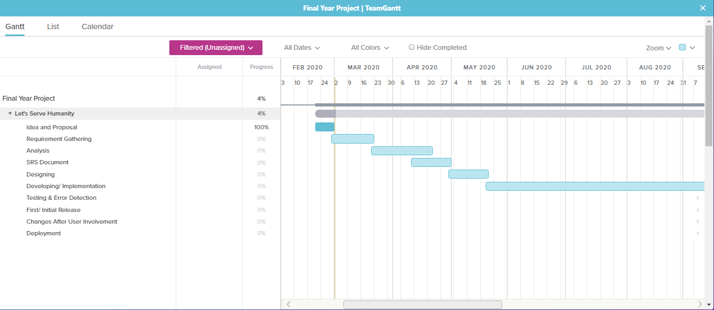

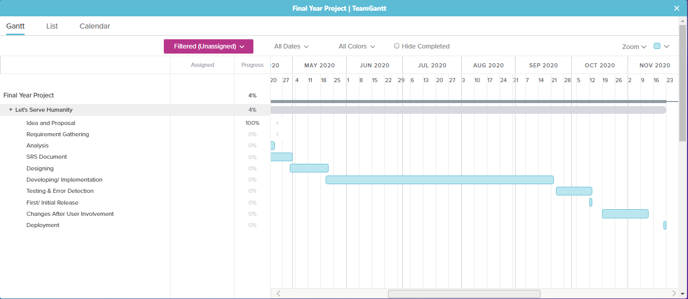

1. **Hardware and Software Requirements**
   1. **Hardware Requirements:**

* High Performance System
* Quad core processor
* KitKat and above (android versions)
  1. **Software Requirements:**
* React Native
* MongoDB (Database)
* NodeJS